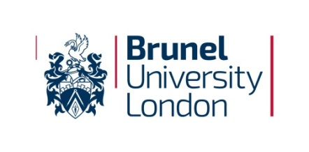

Application Form

Conference and Research Collaboration Fund for Early Career Researchers

Name |  | Job title
College |  | Department / Division
Name & Place of Conference (provide a link to the conference website if possible) |  | Conference Dates*
Names & Places involved in the Research Collaboration |  | Dates*
*Please note this must be within the financial year and all funds must be spent by 31st July 2025.

Section A: Background and Objectives

For conference applications:
- How is the conference theme relevant to your research?
- How will presenting at this conference support your personal, professional and career development?

For research collaboration applications:
- How is the proposed research collaboration relevant to your research, and how will it enhance existing research at Brunel?
- How does this research collaboration support your personal, professional and career development?

Section B: Abstract (for those applying for conference funding only)

Please copy and paste your accepted abstract below.

Section C: Costs

Please specify the funds needed and list the conference or facility access fees (if applicable), estimated travel and accommodation, and sustenance fees. The maximum award is £800. Please also state if you have received any other funding for this (e.g., from the conference organizer, research collaborator, your College or an external organisation).

