
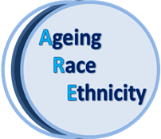
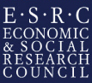

ESRC SEMINAR SERIES 2012-2014: AGEING, RACE AND ETHNICITY
SEMINAR ONE: Black and ethnic minority perspectives on mid and later life.
Brunel University, Hamilton Centre – Darwin Room
Agenda
10.00 – 10.30 Coffee/Registration
10.30 – 11.00 Welcome from the Pro Vice Chancellor and Professor Mary Gilhooly
11.00 – 12.00 Professor Chris Phillipson: 'Placing Ethnicity at the Centre of Studies in Later Life: Theoretical Perspectives and Empirical Challenges'

12.00 – 13.00 Dr Tracey Reynolds: Ageing Well in the Age of Austerity: Exploring Personalised Care Planning among BAME Older People Living in Disadvantaged Neighbourhoods

13.00 – 14.00 Lunch
14.00 – 15.00 Professor Sandra Torres: ‘Understanding of ethnic ‘Otherness’ in relation to elderly care provision/ recipiency: empirical insights from Sweden’
15.00 – 16.00 Dr Kristine Ajrouch: ‘Ethnic Minority Aging in the U.S.: Muslim Perspectives’
16.00 – 16.30 Refreshments
16.30 – 17.00 Discussant – Professor Vanessa Burholt
17.00 – 18.00 Open Floor Discussion
18.00 – 18.30 Champagne, nibbles and networking

OPEN LECTURE
18.30 – 19.30 Professor Christina Victor: ‘Growing old in a foreign land’

