A short guide to organizing your web site

The next stage, after deciding on the contents of your web site and a list of the topics, is to start organising and structuring the information into a set of web pages. Below is a summary of some of the common site structures.

1. Hierarchies

A logical and simple way of web site structure is to put your web pages into a hierarchical fashion. As illustrated in Fig.1 readers can easily reposition themselves by going up and down the pages. You could also include a link to the Home page on each page as a reference point. Hierarchical organisation is not always the best way to structure a site and in some cases could confuse viewers.

A common use of hierarchies is online help systems, where viewers start with a list or menu of main topics, select one topic and they’re taken to a list of subtopics, which will then lead them to a document.

You could put as many subdirectory levels as you want in a hierarchical site, but overdoing this could make site navigation quite difficult.

Home
Fig. 1 Hierarchical organisation

Subfolders
Documents

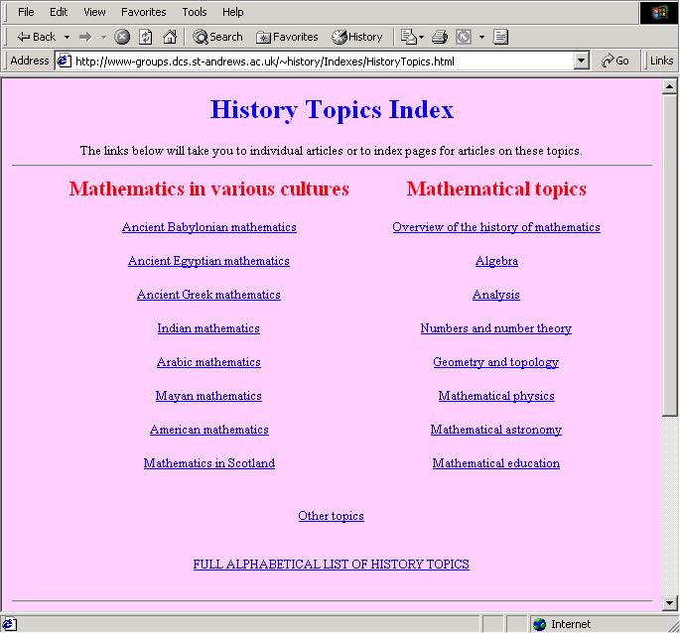

Fig. 2 An example of a hierarchical site.
Clicking on a link, will take you to a subfolder and eventually to a document.

In your reading you may also come across references to ‘hub and spoke’ or ‘star’ arrangements, in which the individual pages are shown as radiating out from a central home page. Obviously, these are just special cases of the hierarchical ‘pyramid’ structure above with only a single sub-level.

2. Linear

Linear or sequential organisation is much like printed documents. As illustrated in Fig. 3, the home page is the introduction and each page follows sequentially from the previous one. You can avoid the rigidity of linear structure by including a simple navigation bar or simple text links on each page.

Home
Fig. 3 Linear organisation

3. Linear with Alternatives

Another way to enhance a linear structure is enabling viewers to deviate from the main path to alternative or additional pages. Your viewers can then rejoin the main chain at any time by following the links in the alternative pages. In this fashion, you could save your viewers a lot of back-clicking.

Home

Fig. 4 Linear with alternatives

4. Linear-Hierarchical

This form of organisation is also popular, for example, in designing FAQ (Frequently Asked Questions) files. You should pay extra attention to the site navigation in this kind of structure. Viewers can easily lose their position if you only rely on back and forward or up and down links.

Fig. 5 illustrates a linear-hierarchical structure.

Home
Fig. 5 Combination of linear and hierarchical

5. Web

In a web structure, web pages and document are linked together with no apparent order- every page could be linked to every page in any manner. This type of organisation could be very annoying to your visitors especially if they loose their orientation. In order to avoid this problem, provide a link to Home and tell your viewers where they are on each page.

Home
Fig. 6 A web structure

Storyboarding your site
Storyboarding usually means arranging a sequence of images for a film or commercial. But you can also storyboard a web site, which can be a helpful way to organize your site structure. Storyboarding is the process of creating a rough outline and sketch of what your web site will look like before you actually write your pages. It could help you to visualise the overall design of your site and work out what content goes on what page.
Here is list of questions you might ask yourself when developing your storyboard:
- How many topics are there for the entire site?
- Which topics will go on each page?
- What are the primary forms of navigation between pages?
- What alternative forms of navigation am I going to provide?
- What will I put on my home page?
As you design the framework of your site, you should review your goals and check how well you’re keeping with your original plan.

Questions and comments to: Hossein.Nili@brunel.ac.uk

